Example – Buying a mobile phone

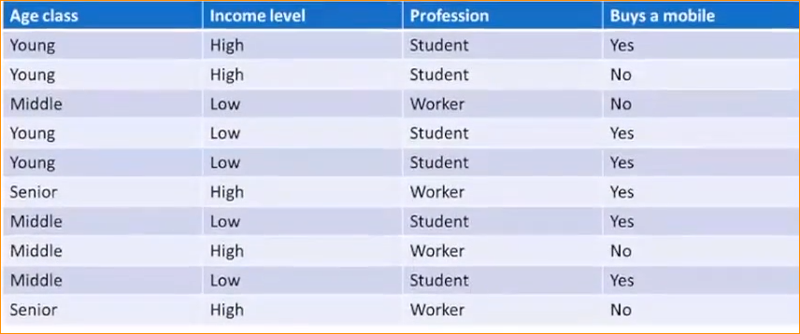

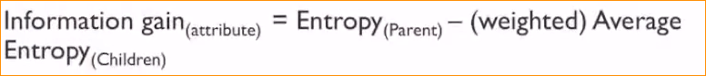

Entropy of parent – Entropy of the entire dataset

To calculate that should consider dependent variable (buy mobile phone or not) –

Calculate how many time class label “yes” has been accord and

Calculate how many time class label “no” has been accord in entire data set in here 10 data set.

Yes = 6 time accord , No = 4 times.

So calculate Entropy of a node :

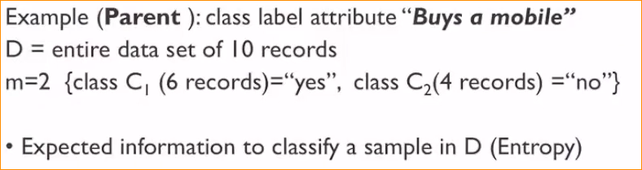

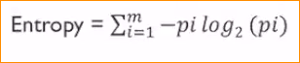 using this and calculate

Pi – Probability of each class appear in the data set

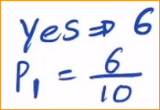 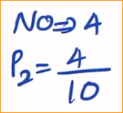

So the calculation – ‘



.

That mean this times of 0.9696 information gathered.

Now for only input feature how much information gather

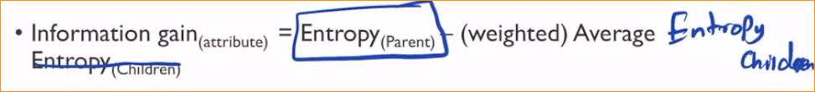

Now calculate the weighted average Entropy children .

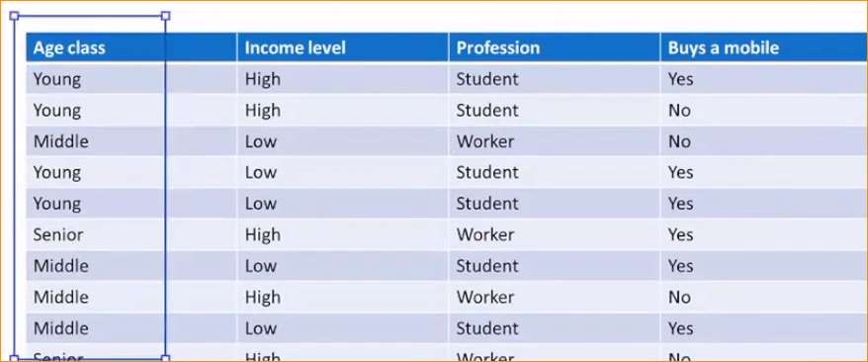

For that we get Age class and calculate weighted average of the entropy.

In Age class – 3 class types, so consider each class at once.

Check one by one those three classes.

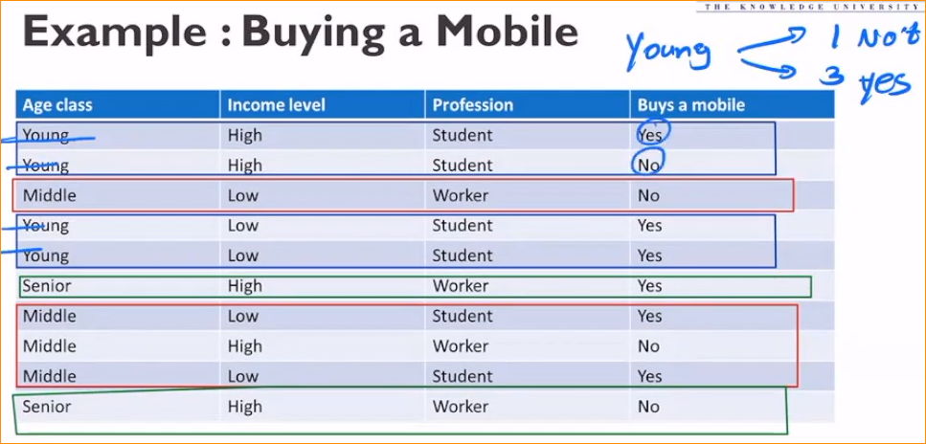

In Young Age category 3 persons are buying the mobile and one is not

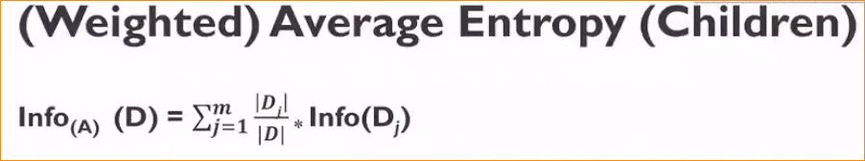

Now apply this information to our equation –

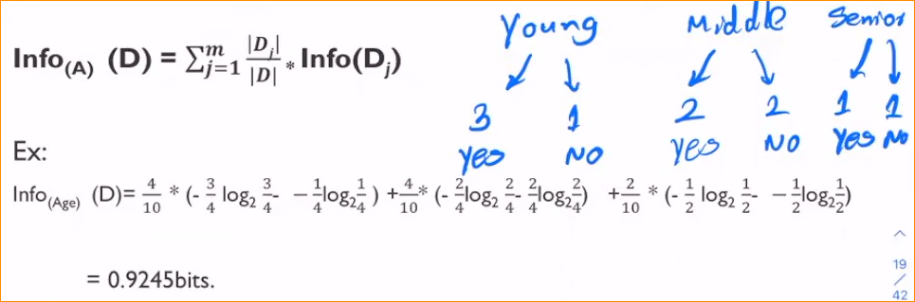

* In here young class type has 4 times out of 10.
* And 3 times out of 4 buy a mobile phone and 1 not buy. Green box
* That details enter our formula.

And consider middle and senior

Now age class is over

Likewise, calculate, income level and profession.

**So How to select the splitting Arribute =**

1. Compute Entropy of the parent node

Info(buys a mobile) = 0.9696

1. Compute information gain of each attribute (Age class, income level, profession)

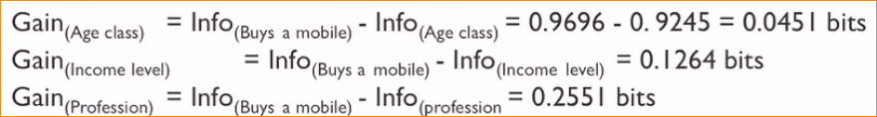

No we have Information gain of relevant classes –

**The attribute with the highest information gain is selected as the spitting attribute**

Ex- Profession has the highest information gain . So that it is selected as the splitting attribute at

Node N (root Node.)

Why take highest - The weight of entropy small mean that data set is **more pure. So the different is high mean the weight average entropy is small. So always get pure data set.**

Now here profession is Student or Worker. So start Profession .

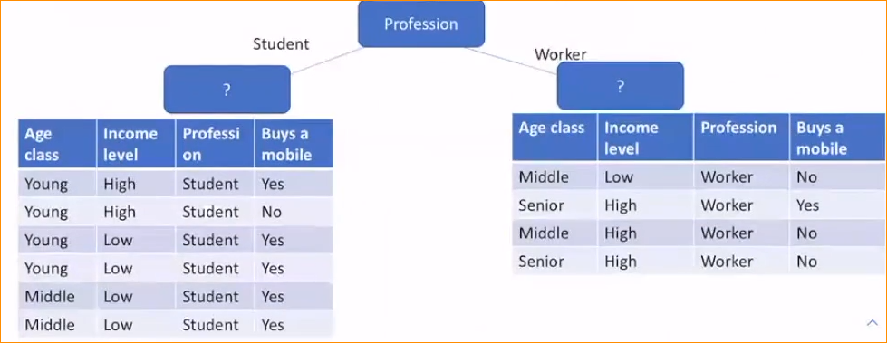

Base on Student and Worker I am going to create two data sets.

1st data set –

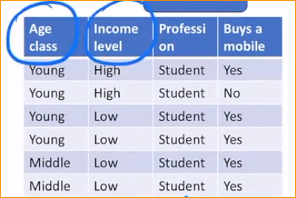

Among Age class and income level which one base on split?

So you should calculate the entropy value again and again

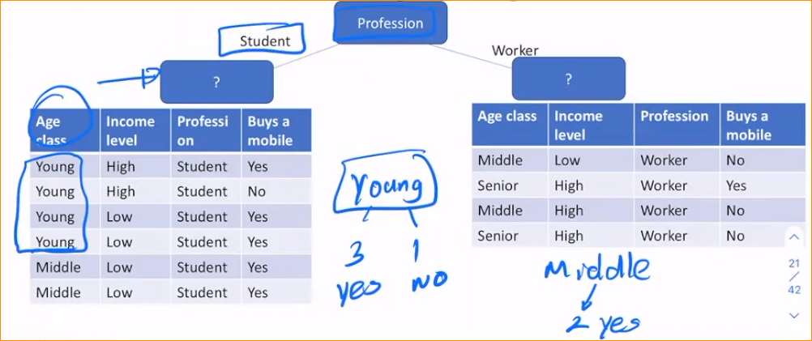

So this calculation should do again and again until class type finish.

Let assume the age has a lowest entropy in the entire dataset.

Here in the middle age always buy a mobile.

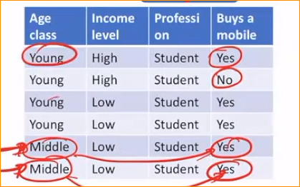

But young you have one “no”

So you have to consider income level as well.